**Report Zhiquan Zhang**

**1.Verification**

To verify the correctness of my program. I create a matrix of 7*7.

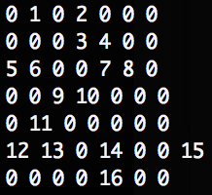

Components: 1, 2-3-4-7-8, 5-6, 9-10, 11-12-13, 14, 16, 15 (8 in total)

Max:5 which contains: 2-3-4-7-8 (5)

Average: (1+5+2+2+3+1+1+1)/8 = 2

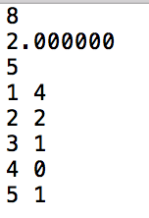

According to my program, the first line is the total number of components, the second line is the average area of the components. The third line is the maximum area. It’s obvious that my program can get the correct conclusion comparing with our analysis.

To be more specific, below is the adjacency list that created by my program. It shows the concrete information of the graph. In addition, the histogram has been shown in the last image.

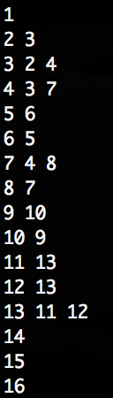

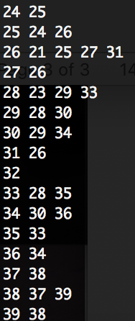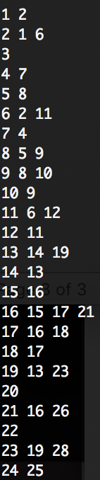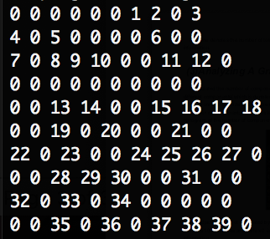 To verify its usage in larger size matrix, I create a 10*10 matrix and let the probability be 0.4. Below the matrix is the adjacency list of the graph.

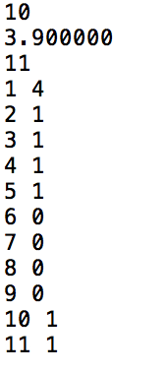

The image above is the analysis of the graph.

To conclude, no matter in small size matrix or large size matrix, my program can both deal correctly with the data.

**2.Experiments**

To gain deeper understanding of the program, I do lots of experiments. I set the size of the grid as 1000*1000 and let probability vary from 0.0 – 1, whose step is 0.02. So I can get 50 groups of data, which contains the average component size, maximum component size and components’ number.

Below are four images that show the relation between probability and average components, max component size and number of components.

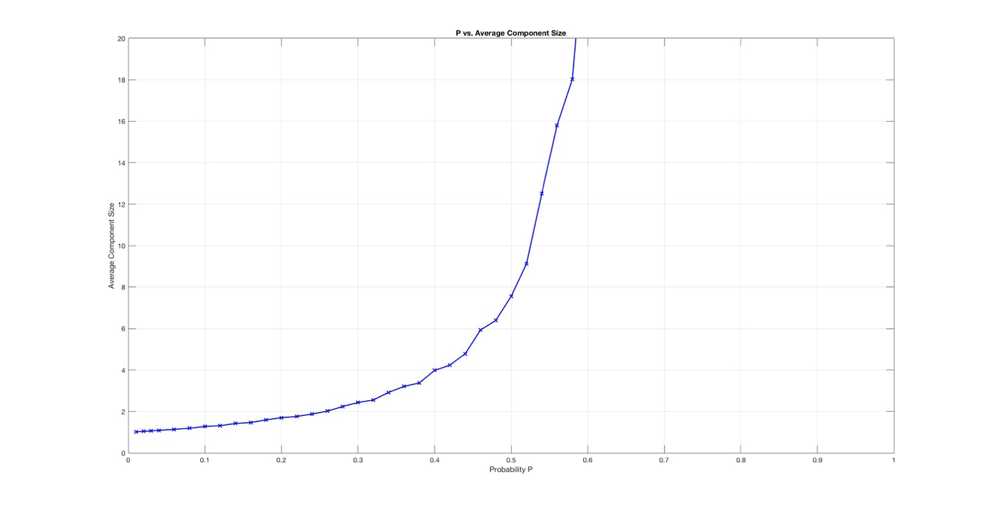

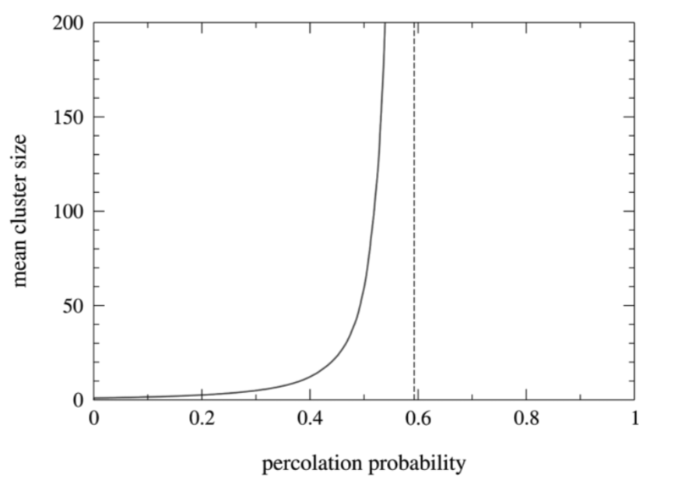

According to the two images above, the latter of which is from the paper, it’s obvious that when we observe the average size of components carefully and rescale it, it roughly has a “critical value” point, around 0.59.

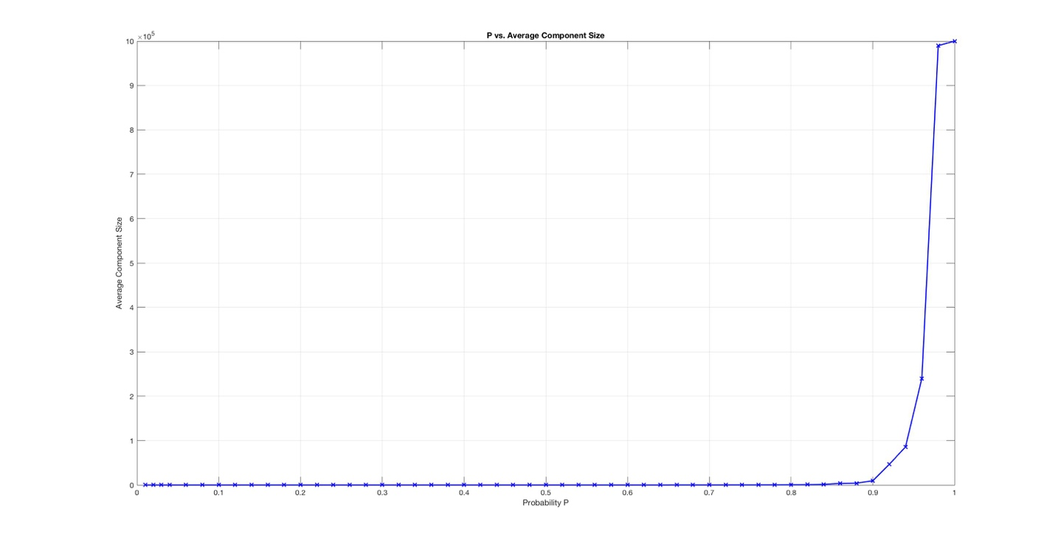

As for other phenomenon, it’s easy to see that the maximum size of components will also increase rapidly when p reaches critical value.

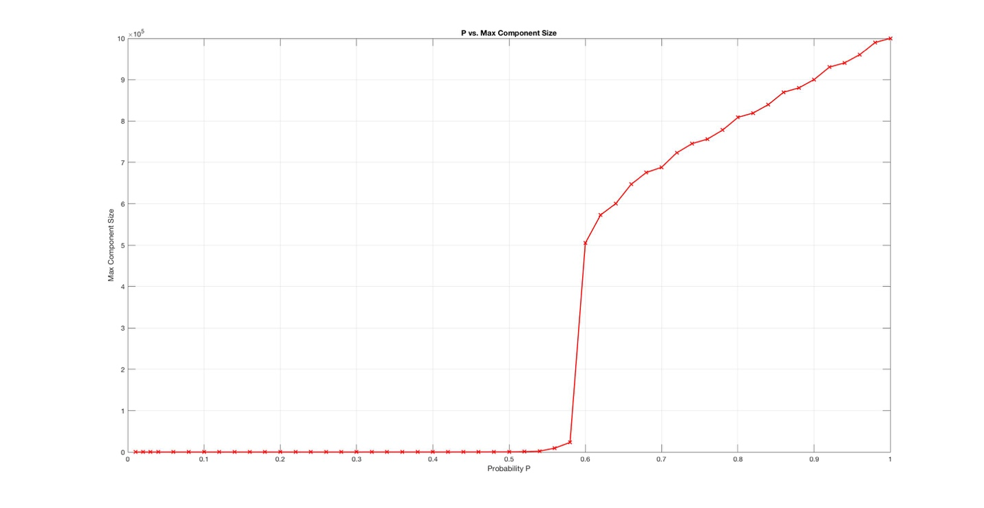

The number of components will first increase with the increasement of the P, and then drop down gradually.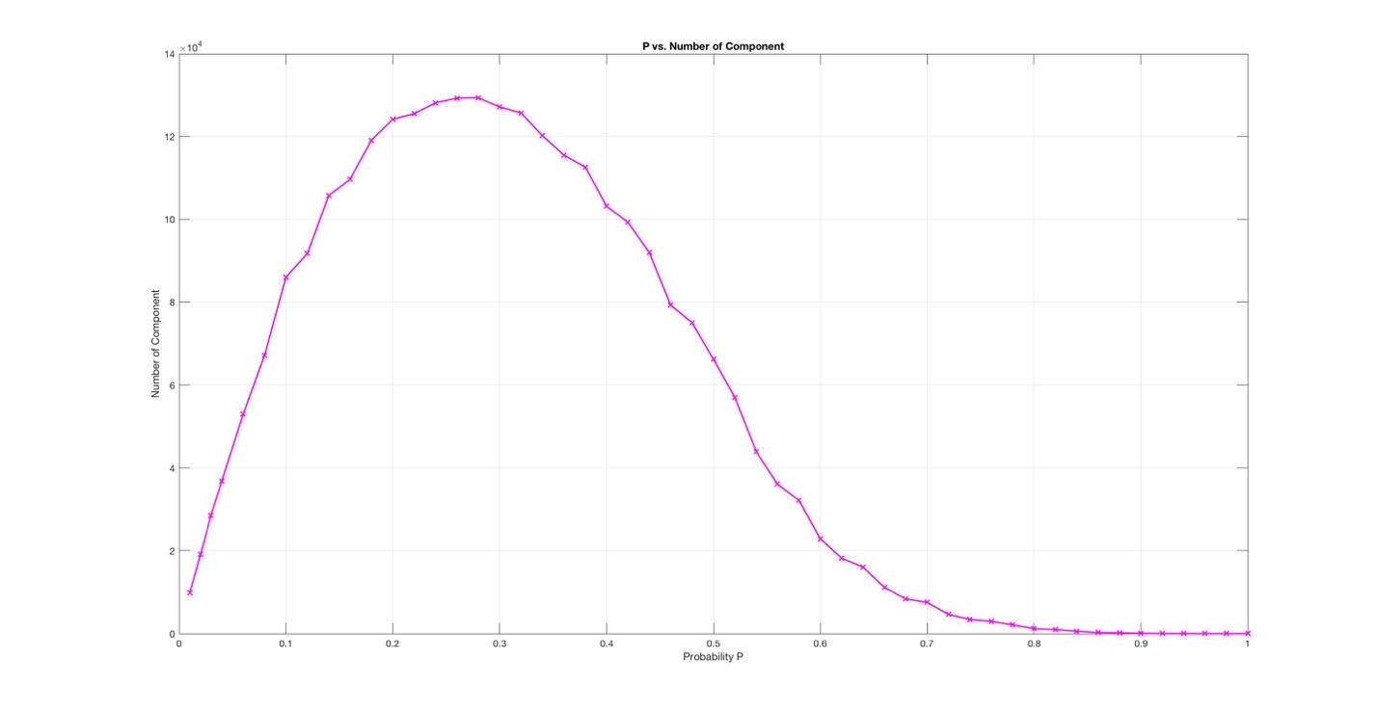

Below are the histograms with the change of P.

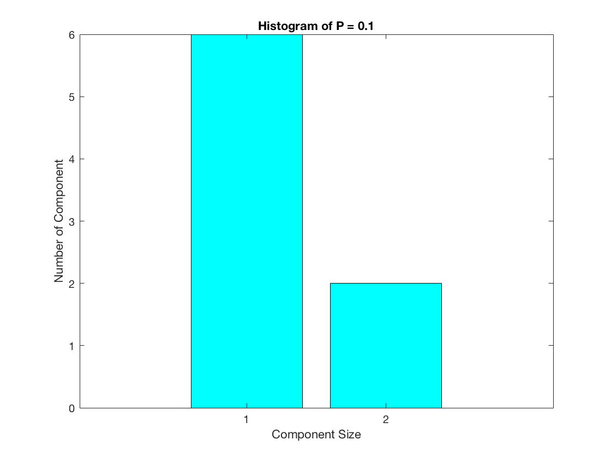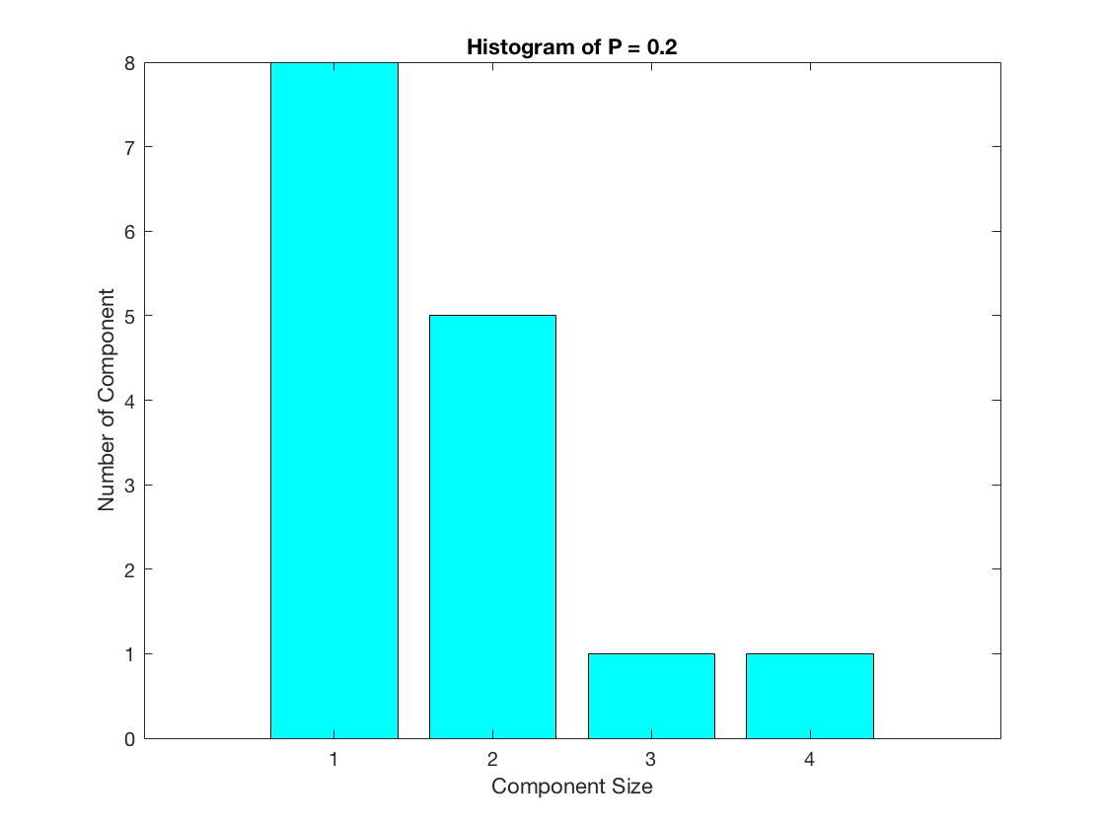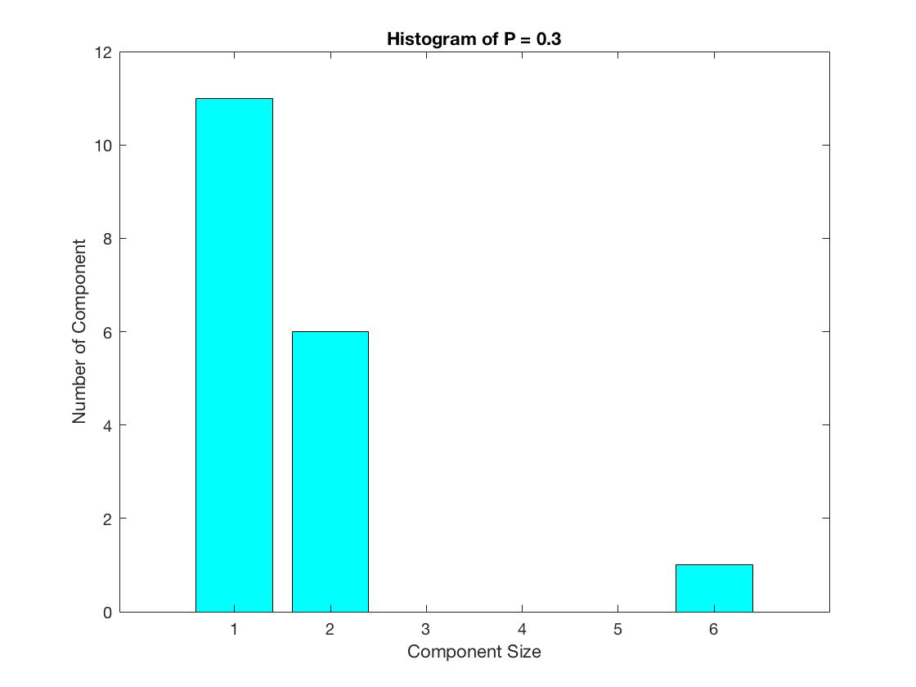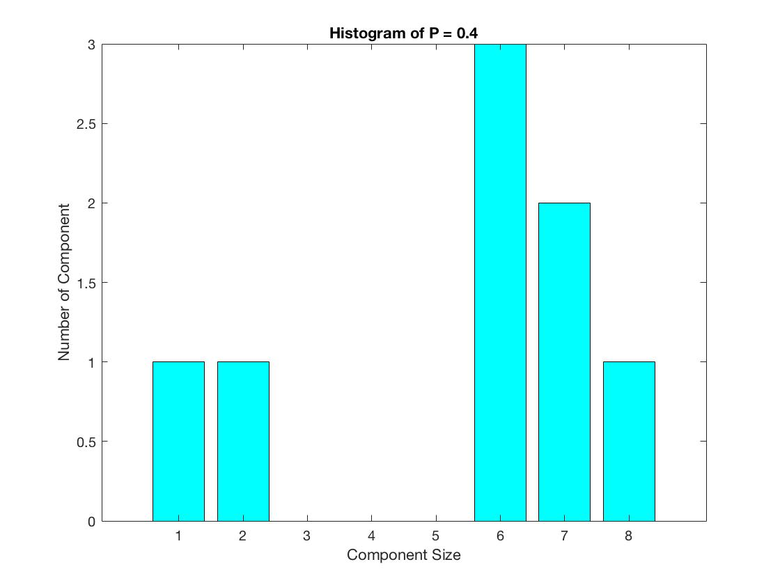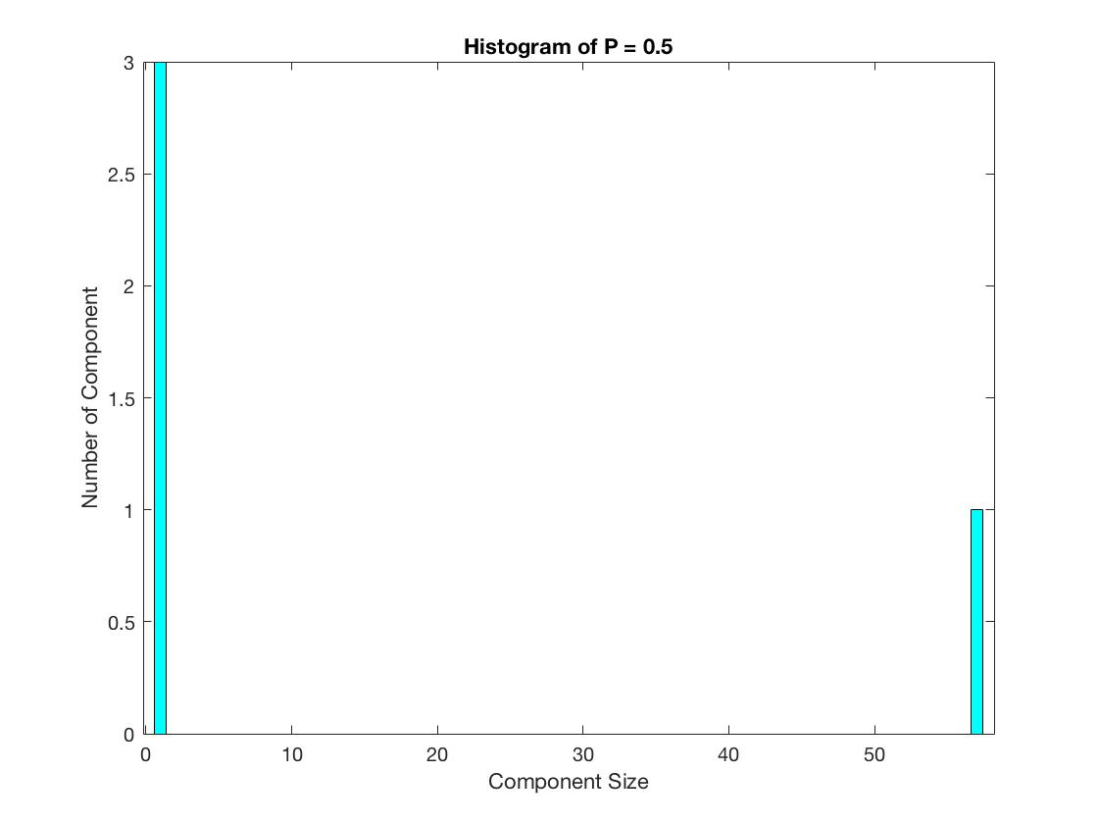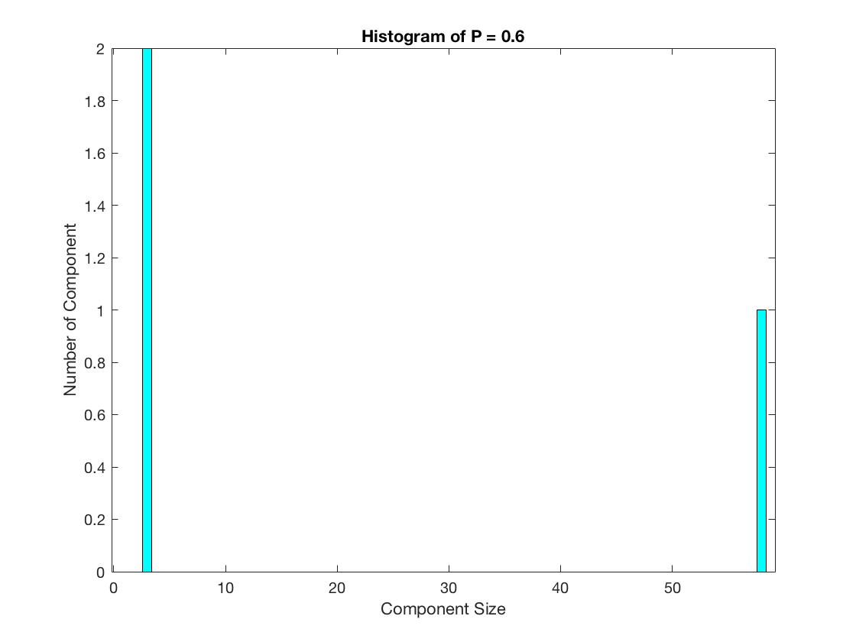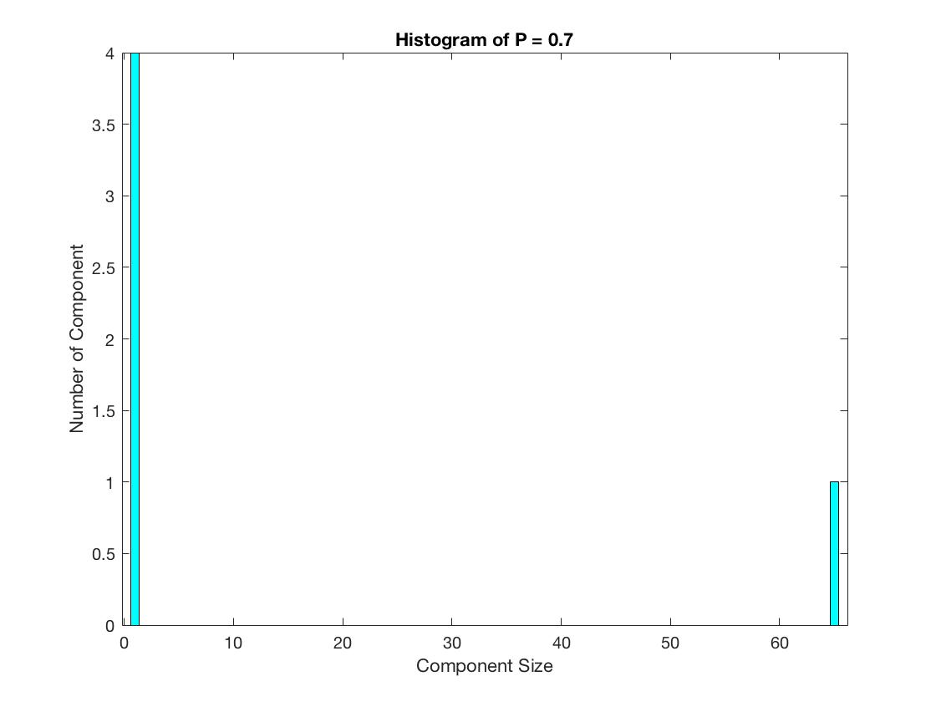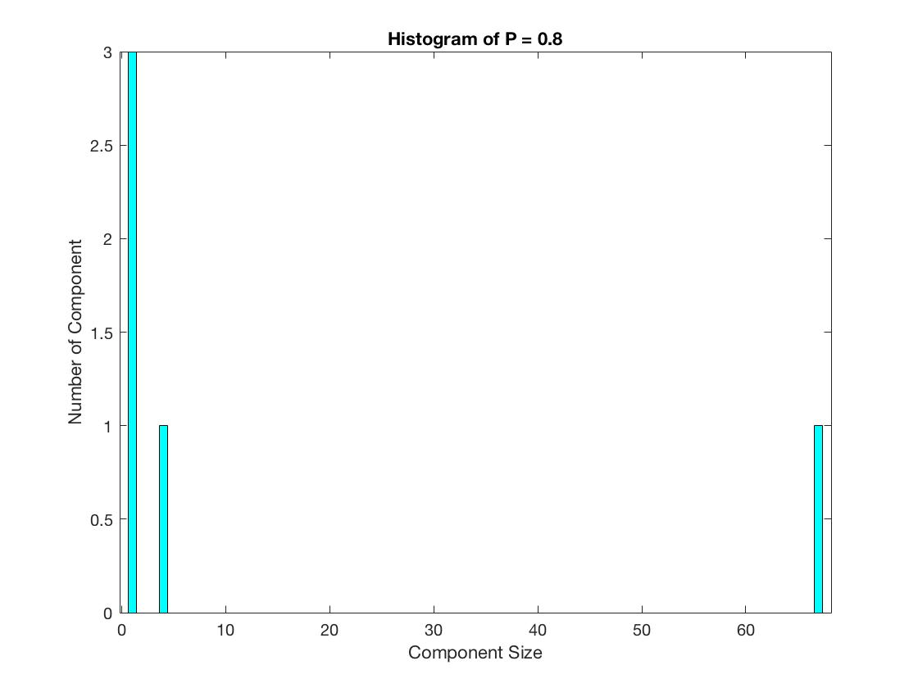

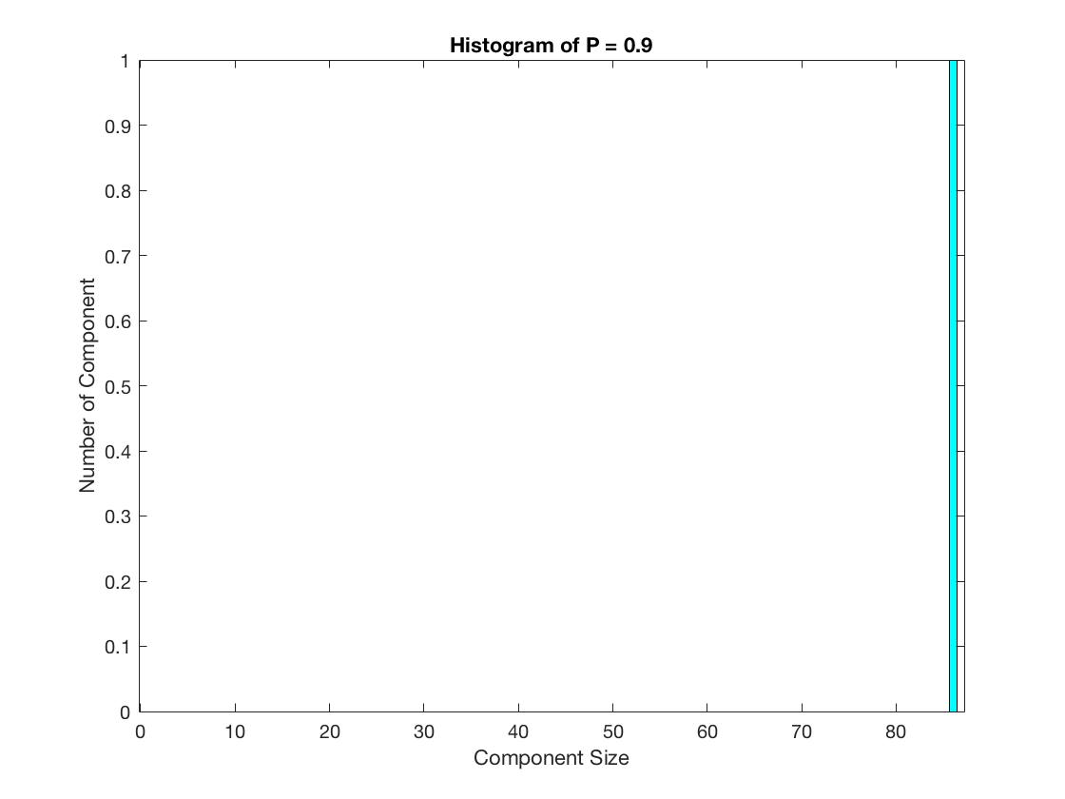

**3.Application and discussion**

Yoshiyuki Inaguma and Mitsuru Itoh have done research on the relationship between carrier concentration, site percolation and lithium ion conductivity in perovskite-type oxides. They focus on the influence from the view point of percolation theory and based on the ionic conductivity. In addition, according to the formula (1) showed below, the ionic conductivity is as below, where Ze is the ionic charge, n is the carrier concentration μ is the mobility of the iron, which depends on the activation energy for the ionic conduction[1].

 (1)

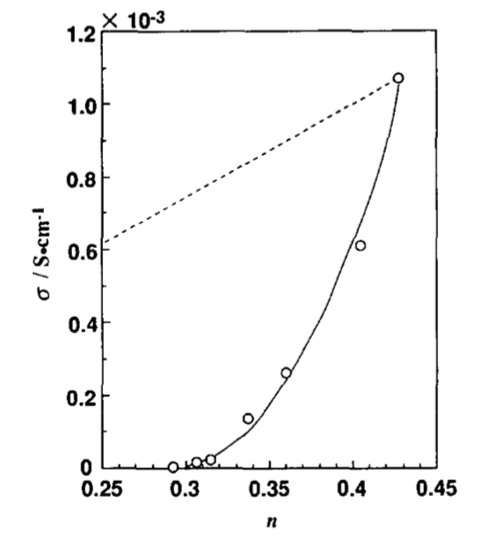After analysis, they thought the mobility if lithium ions is regarded as a constant, and therefore the conductivity is mainly dependent of the carrier concentration. And after the calculation, it should be roughly 0.35(1-y), where y is a ratio.

The broken line in the above image are expected to represent the conductivity’s variance from the concentration. However, the fact is that the conductivity shows the nonlinear dependence on the concentration. And the author of the paper tries to explain this phenomenon through site percolation models.

However, the author found that this model can explain the conductivity for all temperatures (as showed in the image below) so because of the ratio of the concentration of lithium ions to vacancies’ variance.

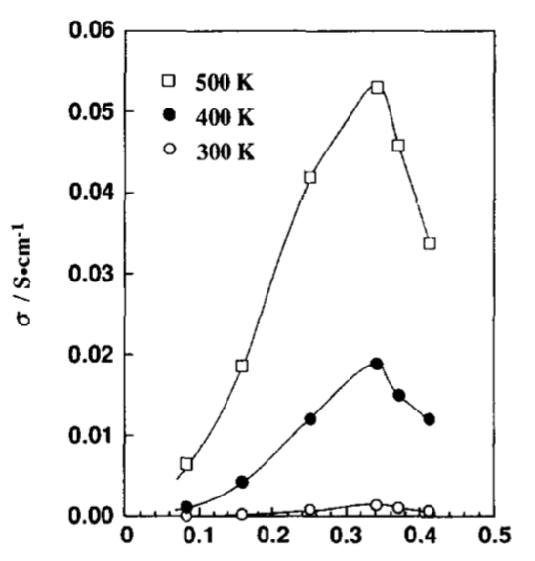

After complex calculation, the author proved that when taking both ratio of the concentration of lithium ions to vacancies’ variance and the site percolation into account, the 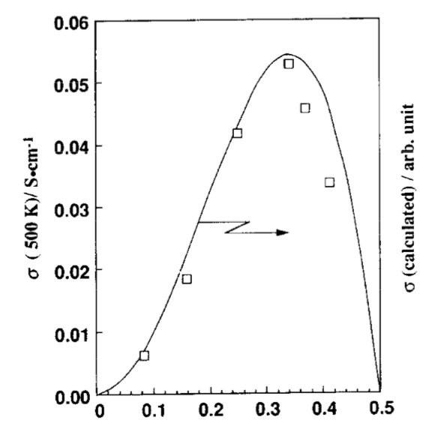phenomenon can be explained more perfectly.

From my perspective, the site percolation model can be a good perspective to solve this chemical problem. However, it’s apparent that this model should couple with more specific mathematical supplement because this model can only explain a rough trend of some phenomenon. But it can’t be denied that this model serves as a powerful tool to solve relevant chemical problems.

[1]Yoshiyuki Inaguma, Mitsuru Itoh. Influences of carrier concentration and site percolation on lithium ion conductivity in perovskite-type oxides[J]. Solid State Ionics, 86-88(1996): 257-260.